Name : Addvija Shekhar Medhekar Div : C Roll No : 39

Practical No :

Problem Statement : Write a C Program to perform arithmetic operation of any two numbers entered by user with appropriate messages.

Algorithm:

Step 1 : Start

Step 2 : Accept the value of 1st number i.e. a

Step 3 : Accept the value of 2nd number i.e. b

Step 4: Calculate addition i.e. A=a+b;

Step 5: Calculate subtraction i.e. B=a-b;

Step 6: Calculate multiplication i.e. C=a\*b;

Step 7: Calculate division i.e. D=a/b;

Step 8: Print A, B, C, D

Step 9: Stop

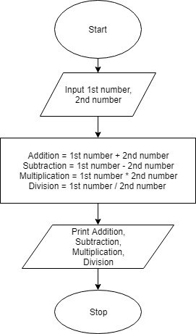

Conclusion: Using Simplecpp software I have calculated the arthematic operations of two numbers by taking input as a (1st number ) and b(2nd number) from user.